**Testing of Fhv fee**

**1.From Seaport service without stops**

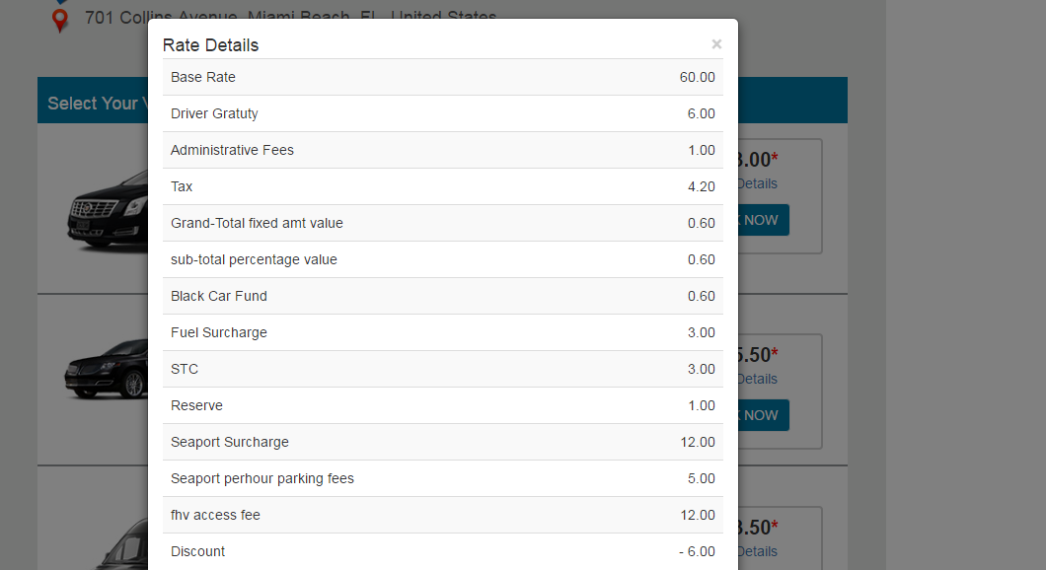

**2 From Seaport service with stops**

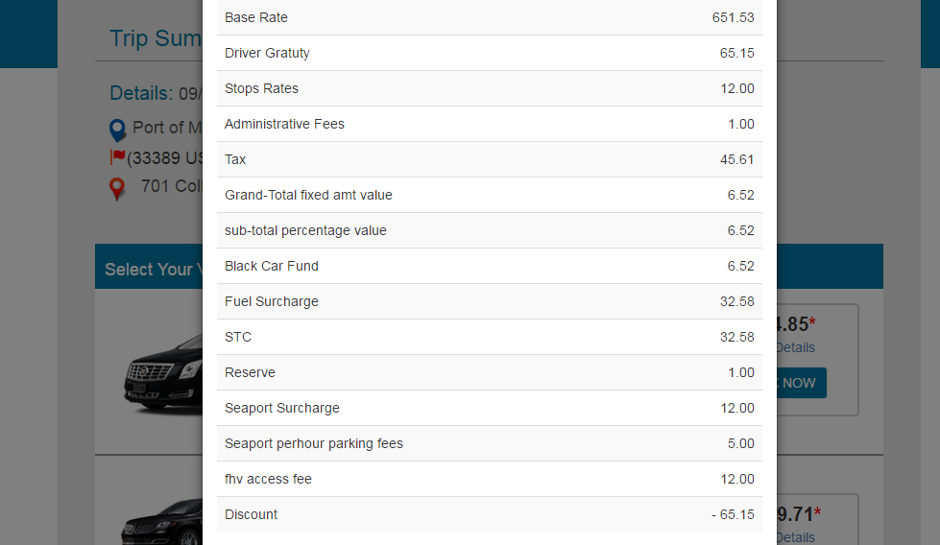

**3. To Seaport without stops**

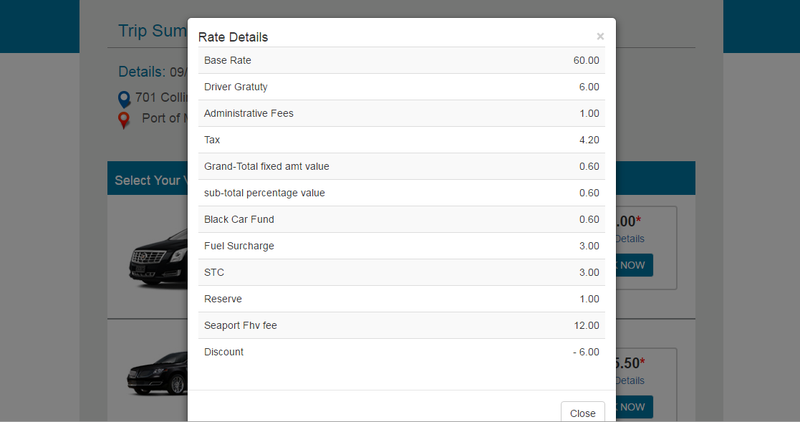

**4. To Seaport with stops**

